
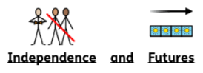
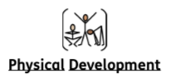
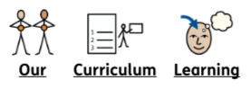

In Creative Arts we are looking at ourselves and important things around us. We will be using a range of materials through drawing, painting and sewing.

Our topic this term is Transition and Change. We will learn about our feelings (The Zones of Regulations). We will spend some time getting to know each other. Pupils will explore our indoor and outdoor environment and will play games and interact with each other.

In Autumn 1 we will continue dance (Monday) and Leeds United (Thursday) sessions. In PE pupils will develop a variety of skills focusing on throwing and catching. Pupils will work on developing their flexibility, strength, control and balance.

Key Stage 1
Autumn 1
2025 - 2026

Me and My World

