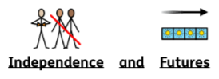
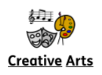

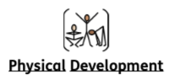
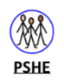
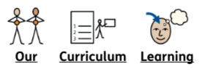

Our topic this term is Transition and Change. We will learn about our feelings (using The Zones of Regulations approach) and spend time getting to know each other as a class. Pupils will explore their indoor and outdoor environment. We will also focus on developing independence when changing for PE.

In Creative Arts we are looking at ourselves and important things around us. We will be using a range of materials and methods to mark make and make creations. We will also explore role play, dressing up as characters and people who help us in our community.

Me and My World
Our Wider World lessons will link closely to our topic. The children will talk about themselves including their likes and dislikes and learn about their body. We will them look at our family and how they help us. We will also learn about our community, learning about the people who help us at school, our class, our school community and the local community.

In PE we will develop a variety of ball skills, focusing on throwing and catching. Pupils will work on developing their flexibility, strength, control and balance. We will also continue dance (Thursday morning) and Leeds United (Thursday afternoon) sessions.
PE will continue to be on a Thursday afternoon.

In PSHE we will explore how we can play and work together. We will look at our classroom rules and classroom jobs, putting these into our routine. We will also develop our understanding of the Zones of Regulation and each create a personalised toolkit to help us co-regulate and regulate our emotions throughout the school day, as well as look at what we look like when we learn.

Maple
Autumn Term 1
2025 - 2026

Me and My World

