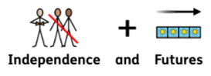
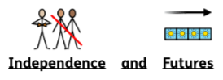
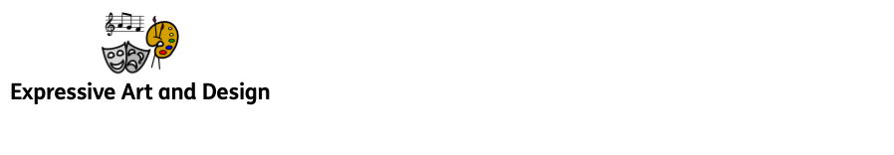
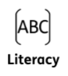
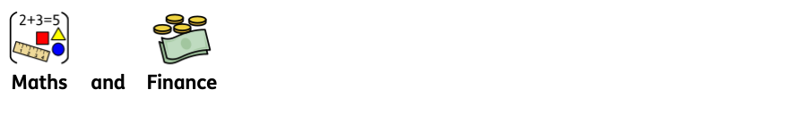
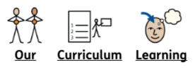

This half term we will be focusing on, transition and change. We will explore our new classroom and the outdoor environment, as well as different areas in school. We will begin to learn about the Zones of Regulation and different feelings.

During Autumn 1 half-term, we will be exploring paint. We will observe what happens when we mix 2 colours together by high fiving our friends and creating a new colour. We will look at the features of our faces and paint portraits. We will also sing songs and nursery rhymes and explore musical instruments, learning to tap to the beat of the music and enjoy making different sounds.

All children will develop their comprehension, word reading, and writing skills. Some children will begin to write their names. We will share the stories; All About Me, Super Duper You, Whoever You Are, From Head to Toe, Big Feelings and The Five Senses in a variety of ways including role-play, the use of story sacks and sensory stories to promote a love of reading and enjoyment.

EYFS
Autumn Term 1
2025 - 2026

All About Me!

This half-term we will be learning about more than, fewer than and the same. We will explore and build with shapes and objects. We will look at patterns and repeats in songs and stories. We will also sing number songs and nursery rhymes.

