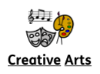
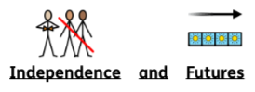
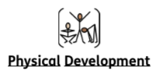
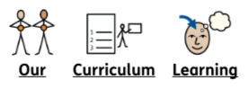

In Creative Arts we are looking ourselves and important things around us. This will involve self portraits and images of the local community. We will be using a range of materials through drawing, painting and sewing.

Our Independence and Futures lessons will be focusing on developing our independence when taking part in cooking activities. We will be making a selection of sweet and savoury items.

Our Physical Development topic this half term is Ball Skills. We will practise throwing, catching, rolling and bouncing balls. We will also look at how we can safely travel with a ball in different directions. When we have practised each skill, we will then incorporate these skills into games we can play together.

Key Stage 2
Autumn 1
2025 - 2026

Marvellous Me!

