

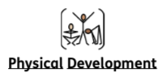
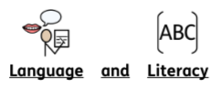
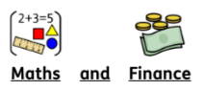
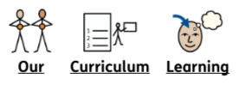

During this PSHE topic we will start by defining what kindness and unkindness look like, and then dive into the serious topics of bullying and abuse, exploring how to recognise and address them. The lessons will also focus on the challenges of peer pressure and equip students with strategies for managing these pressures while understanding their personal responsibilities. Finally, we'll examine the broader systems of support, learning about available support services and the relevant laws designed to protect people from bullying.

Again as part of additional responsibilities in KS4, and in order to promote independence and decision making skills, pupils in Key Stage 4 have input into things they would like to cook in Food Technology, This half term they have already chosen sausage and mash and a range of pasta dishes.

This half-term we will be focusing on ball skills, focusing on team play, techniques, and game strategies. We will also be focusing on developing an understanding of preparing for sporting activity looking at specific warm ups, stretches and muscle groups. Please can pupils bring in their kit every Friday.

Year 10
Autumn Term 1
2025-2026

This half term we are reading ‘The Wild Robot’ by Peter Brown. We are making links between our book and our topic of Space. Some pupils are continuing the ‘Read, Write, Inc’ scheme to enhance their reading and writing skills. It would be fantastic if you could continue to support your child by reading with them at home.

This half term we are focusing on various aspect of ‘Place Value’ as well as the application of money skills.

