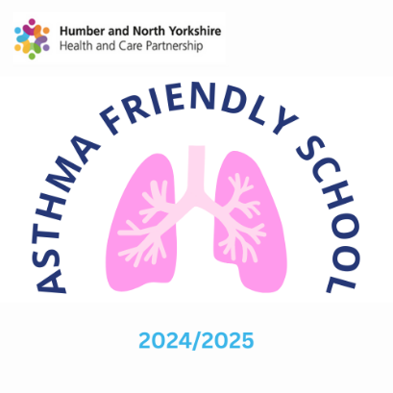

Date: 31/03/2025

Dear Parents/Carers,
I am happy to inform you that your child's school: The Forest School has been awarded Asthma Friendly School status for 2024/2025. This award is valid for 2 years from the date of this letter.
To gain this award, the school has self-assessed that the following Asthma Friendly Standards are in place:
- The school has an Asthma Champion.
- The school has an Asthma Policy.
- There is a register of all children with Asthma in school.
- The school keep an emergency inhaler and spacer.
- The school requests a Personal Asthma Action Plan for children with Asthma.
- The school communicates with parents/carers to keep children with Asthma safe.
- School staff receive Asthma training and have an awareness of how to support children with Asthma.

Asthma is a very common condition affecting around 3 children in every classroom across the UK. You can find out more about Asthma and other common childhood conditions at:
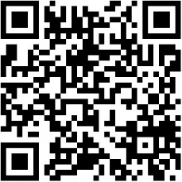

https://www.hnyhealthiertogether.nhs.uk/

Best Wishes

Jen Brownbridge
Children and Young People's Transformation Team
NHS Humber and North Yorkshire ICB

