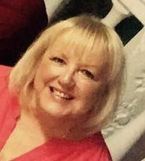
A big hello again to both the pupils and parents of Class BS.
It was lovely to speak to you last week and hear about the things that you have been doing whilst we are staying safe at home.
I know lots of you are missing school and your friends, but we will be together again.
I am sending you another week’s tasks for you to do at home. I hope you find them useful. However, there is no pressure to do these activities. They are there to give you ideas only.
This week we are thinking about the traditional story of Jack and the Beanstalk again. I hope you enjoyed reading it last week.
I think about you all every day and I hope to speak to you again this week to see if I can be of any help. If you wish you can always e-mail at smithb@forest.n-yorks.sch.uk
Please take care everyone and stay safe.

This Photo by Unknown Author is licensed under CC BY-SA
Beth Smith

