Pegs on a hanger
You will need:
- Number cards 0-10, with two number 5’s. Post it notes will work well as number cards.
- A coat hanger
- Ten clothes pegs
- Tea towel
(If you don’t have pegs, you can create the same effect by hanging paper clips, safety pins or even hair bobbles from the coat hanger.)
How to play:
- Lay out the number cards face up.
- Peg 10 pegs along the coat hanger. Count the pegs, touching and saying the numbers as you go -1,2,3, etc.
- Ask your child to turn around. Split the pegs into two groups on the hanger . Cover one group of the pegs with the tea towel.
- Ask the child to turn around and choose the number card that matches the number of pegs that are hidden.
- Reveal the hidden pegs. Did they get the correct missing number?
- Write down the addition sum for the pegs
e.g. 6+4 = 10
7. Play again making a different number sentence.
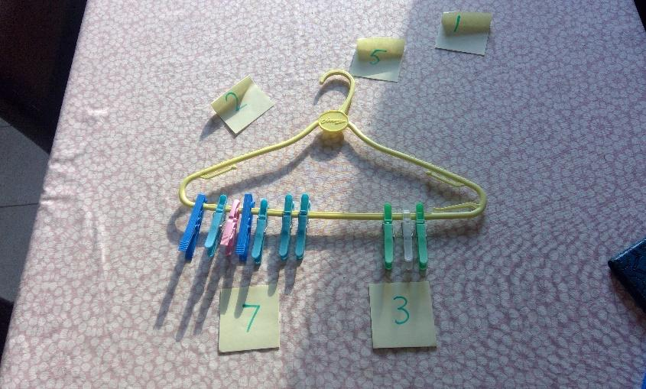

You can extend this activity by using 12, 15 or even 20 pegs!

