How many in a shoe!

You will need small objects e.g. Lego, bricks, buttons, conkers, shells, figures or animals etc – pencil and paper.
What to do:
- Choose a shoe or a slipper
- Choose some small toys, bricks, shells or other counting objects.
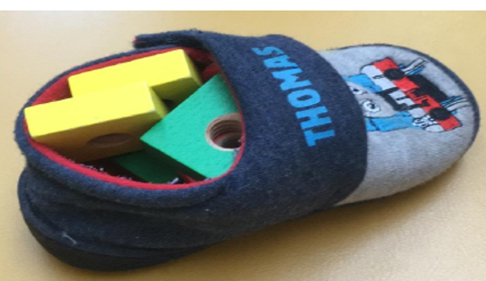
- Discuss how many you think will fit, but not overfill the shoe …. Have a guess, estimate.
- Write down your estimation

- Now take out the things one at a time
- Count the things as you take them out.
- How many were there?
- How close were you to your guess?
- Write the number
- Play with a friend and see who has estimated most closely.
