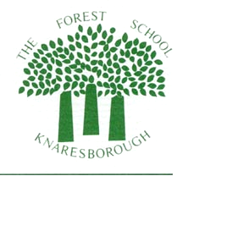
Hello to pupils and parents of Class NK/VJ
It was so lovely to speak to you last week and hear about the things that you have been doing whilst we are staying safe at home.
It was great to hear that lots of you are keeping busy and that you are also getting time to spend outside in the lovely weather. Well done to those who have been doing lots of exercising and to those who have been checking on their bug hotels to see if anyone has moved in. I have really enjoyed seeing the pictures that some of you have sent me.
I am sending you some more ideas for your learning tasks this week to do at home. I hope you find them useful, however, there is no pressure to do these activities. They are there to just give you ideas. This week I have included the worksheets which accompany the tasks if you are able to print them out at home. There is also a template for your diary, but again, if you have started your own diary that’s fine. It is just an idea to help you.
I am thinking about you all and I hope to speak to you again this week to see if I can be of any help.
Please take care everyone and stay safe.

This Photo by Unknown Author is licensed under CC BY-SA
Nikki Kordyga
kordygan@forest.n-yorks.sch.uk

