Prompt 1

Look at this week’s picture.

I can see _______________________________________________________________

I like __________________________________________________________________

I don’t like _____________________________________________________________

What is happening this week? Describe it using pictures, words or sentences.

How does this week’s story make you feel?

I feel _____________________________

I feel like this because _______________

__________________________________

__________________________________

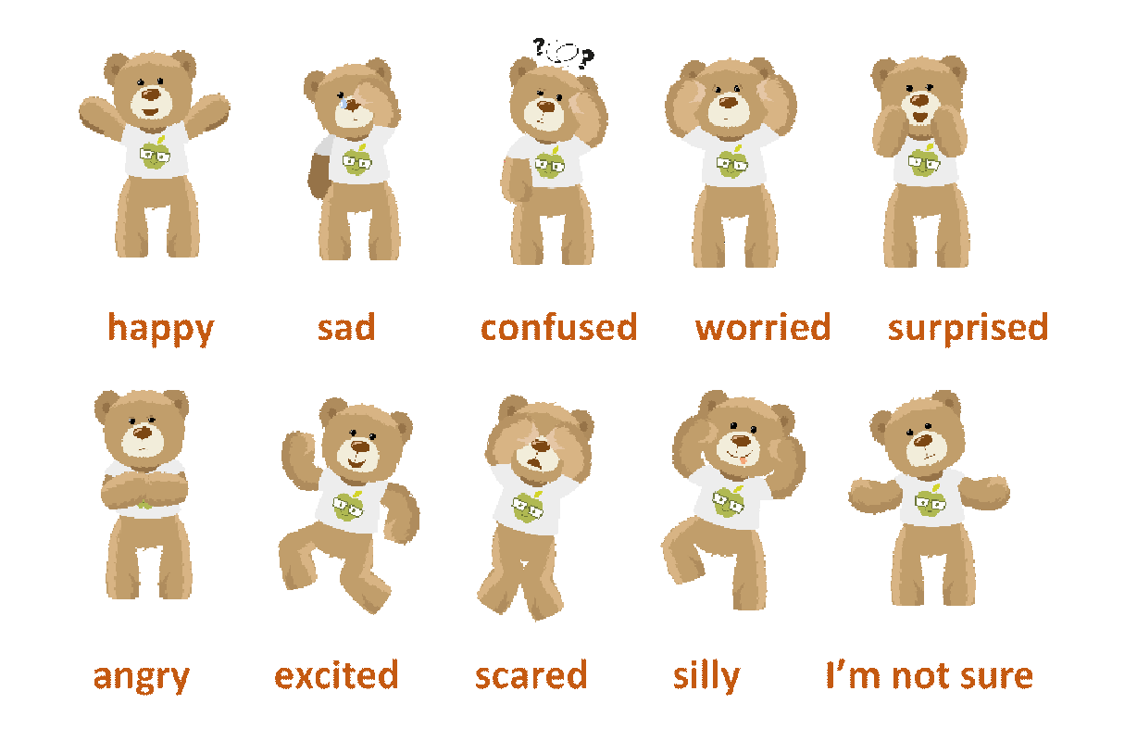

Where is it happening? Can you locate it on a map?

I think
I feel
I prefer
I know
I believe
The best thing about
The worst thing about

What is your opinion?

Share your thoughts on our online discussion board: www.picture-news.co.uk/discuss

